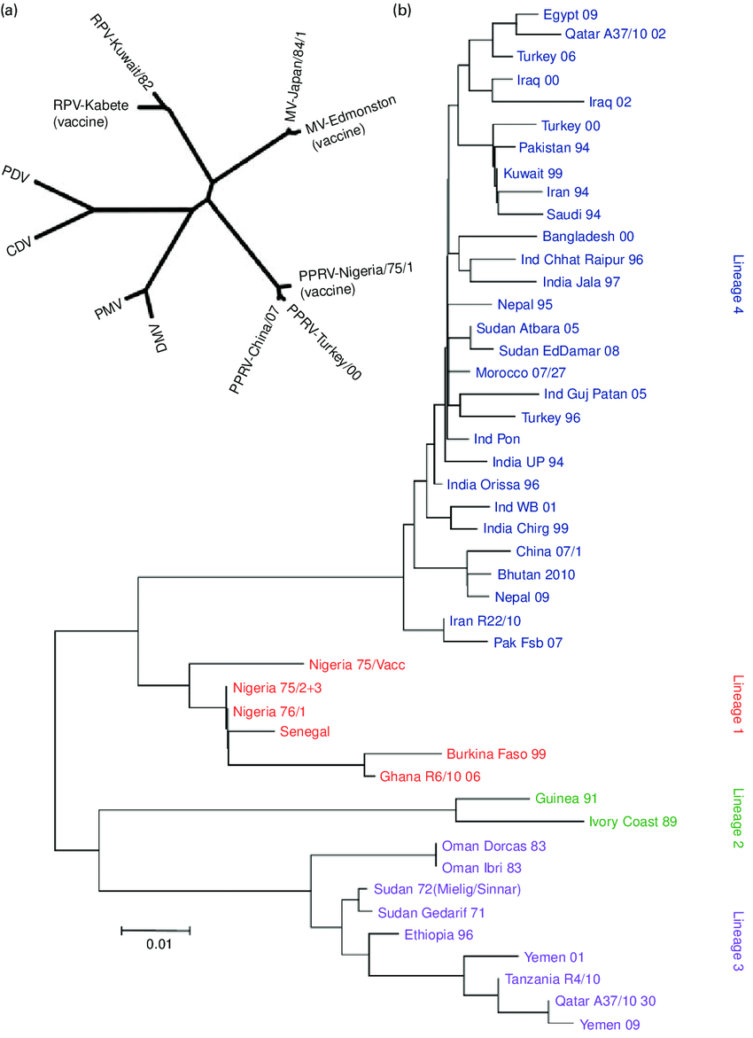
Figure.1. Phylogenetic analysis in peste des petits ruminants (PPR) (a) The relationships between rinderpest virus (RPV), PPR virus (PPRV) and other morbilliviruses are illustrated using a phylogenetic tree based on the full N gene sequences of the indicated viruses. The tree was drawn with branch lengths determined by the evolutionary distances used to infer the phylogenetic tree. CDV Canine distemper virus, DMV Dolphin morbillivirus, MV Measles virus, PDV Phocine distemper virus, PMV Porpoise morbillivirus. (b) Phylogenetic tree showing representative members of the four known lineages of PPRV based on a 320 base region in the F gene. Phylogenetic analysis was conducted using the program MEGA4 (Tamura et al., 2007)

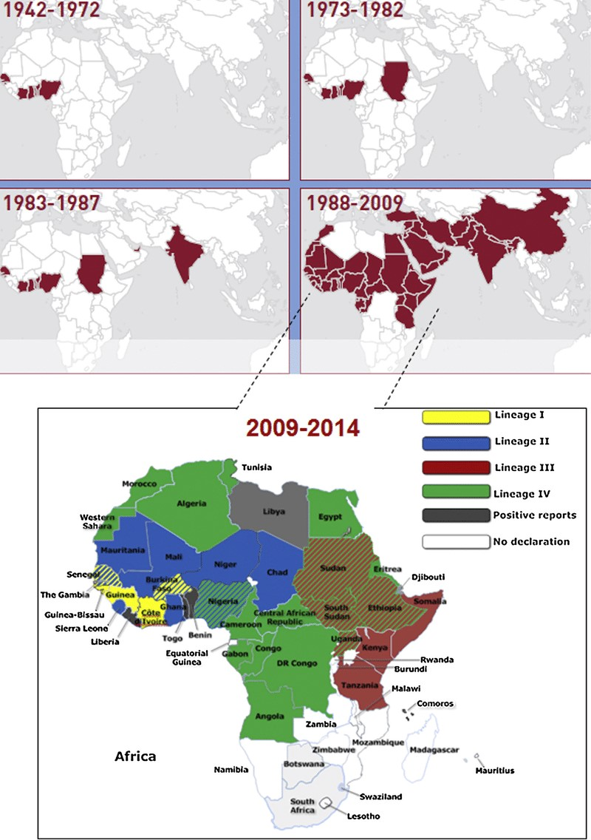
Figure.2. Global distribution of PPRV lineages (Parida et al., 2016)
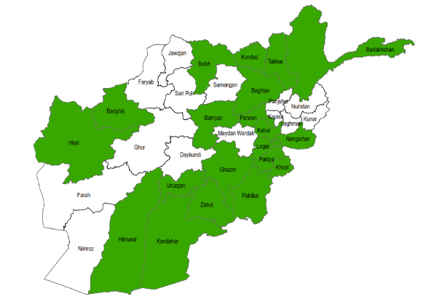
Figure.3. Afghanistan Provinces in which DCA-supported VFUs vaccinated livestock (Azizi, N., & Farid, A. (2010)

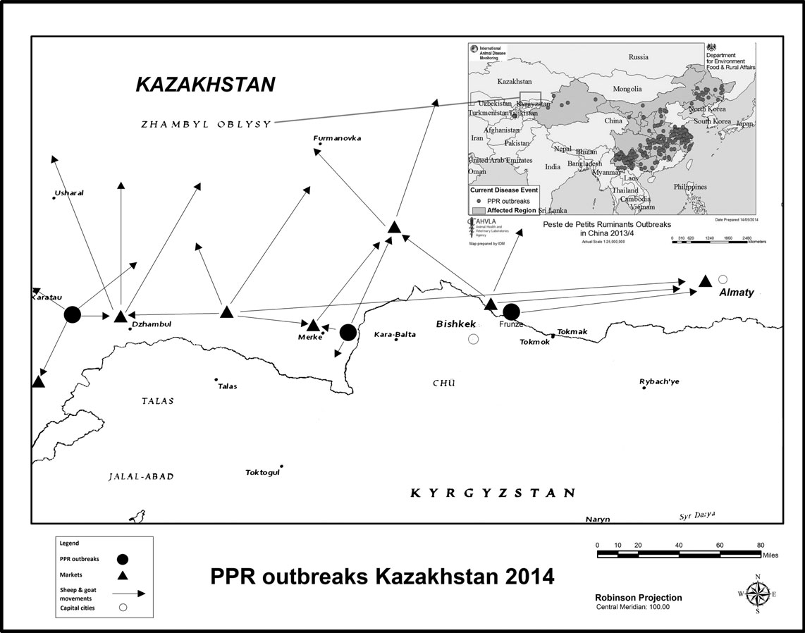
Figure.4. Map of recent PPR outbreaks reported in Asia and Zhambyl oblast marked by the rectangular box on the continental map (AHVLA 2014). The oblast map extracted to show the three outbreak sites (black dots) reported in this study in the Zhualy, Merke and Korday districts (rayon) and showing small ruminant movement and trade patterns (arrows) (Kock et al., 2015)
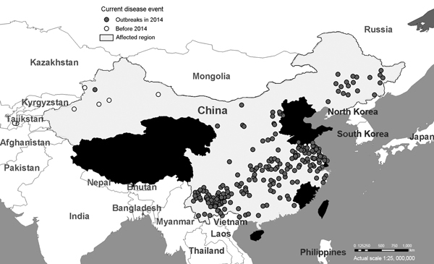
Figure.5. Outbreaks of peste des petits ruminants virus (PPRV) across China during December 2013–May 2014. Data are from ProMed alerts during the period described. (ProMed China. 2014)
References:
TAMURA, K., DUDLEY, J., NEI, M. & KUMAR, S. (2007) MEGA4: Molecular Evolutionary Genetics Analysis (MEGA) software version 4.0. Molecular Biology and Evolution 24, 1596-1599.
Parida, S., Muniraju, M., Altan, E., Baazizi, R., Raj, G. D., & Mahapatra, M. (2016). Emergence of PPR and its threat to Europe. Small Ruminant Research, 142, 16-21.
Azizi, N., & Farid, A. (2010). Peste des petits ruminants in Afghanistan. Ministry of Agriculture, Irrigation, and Livestock, Kabul, Afghanistan. https://oiebulletin.com/?panorama=ppr-control-and-eradication-programme-in-afghanistan-2.
Kock, R. A., M. B. Orynbayev, K. T. Sultankulova, V. M. Strochkov, Z. D. Omarova, E. K. Shalgynbayev, N. M. Rametov, A. R. Sansyzbay, and S. Parida. (2015): Detection and genetic characterization of lineage IV peste des petits ruminant virus in Kazakhstan. Transboundary and emerging diseases 62, no. 5: 470-479.
ProMedMail. Peste des petits ruminants-China (11): Sheep, goat, spread, OIE, request for information. ProMed 2014. May 5. http://www.promedmail.org, archive no. 20140511.2465094.

